EXPERIMENT 11

PROCEDURES

Aim:

* Create a table with attributes students and marks.
* Insert values into the table.
* Create a procedure to get the merit students (marks > 50).
* Create a procedure to get marks of a given id (using in).
* Create a procedure to display highest marks (using out).
* Create a procedure to get marks of a given id (using in and out).

MySQL:

create table stud_marks(id int, marks int);

insert into stud_marks values (1, 30), (2, 40), (3, 50), (4, 60), (5, 70);

select * from stud_marks;

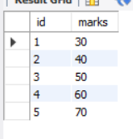

**procedure to get the merit students:**

DELIMITER //

create procedure get_merit_students()

begin

select * from stud_marks where marks > 50;

end //

DELIMITER ;

call get_merit_students();

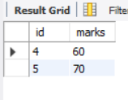

**procedure to get marks of a given id**

DELIMITER //

create procedure get_marks(IN id1 int)

begin

select marks from stud_marks where id = id1;

end //

DELIMITER ;

call get_marks(3);

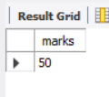

**procedure to display highest marks**

DELIMITER //

create procedure get_max_marks(out highest int)

begin

select max(marks) from stud_marks;

end //

DELIMITER ;

call get_max_marks(@highest);

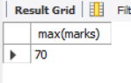

**procedure to get marks of a given id**

DELIMITER //

create procedure getMark(INout id2 int)

begin

select marks from stud_marks where id = id2;

end //

DELIMITER ;

set @m = 5;

call getMark(@m);

